**Name:** Soham Bhoir

**Roll No.:** 16010420117

**Batch:** A4

**Experiment: 2**

**Results: (Program / Steps with screenshots)**

**Screenshots:**

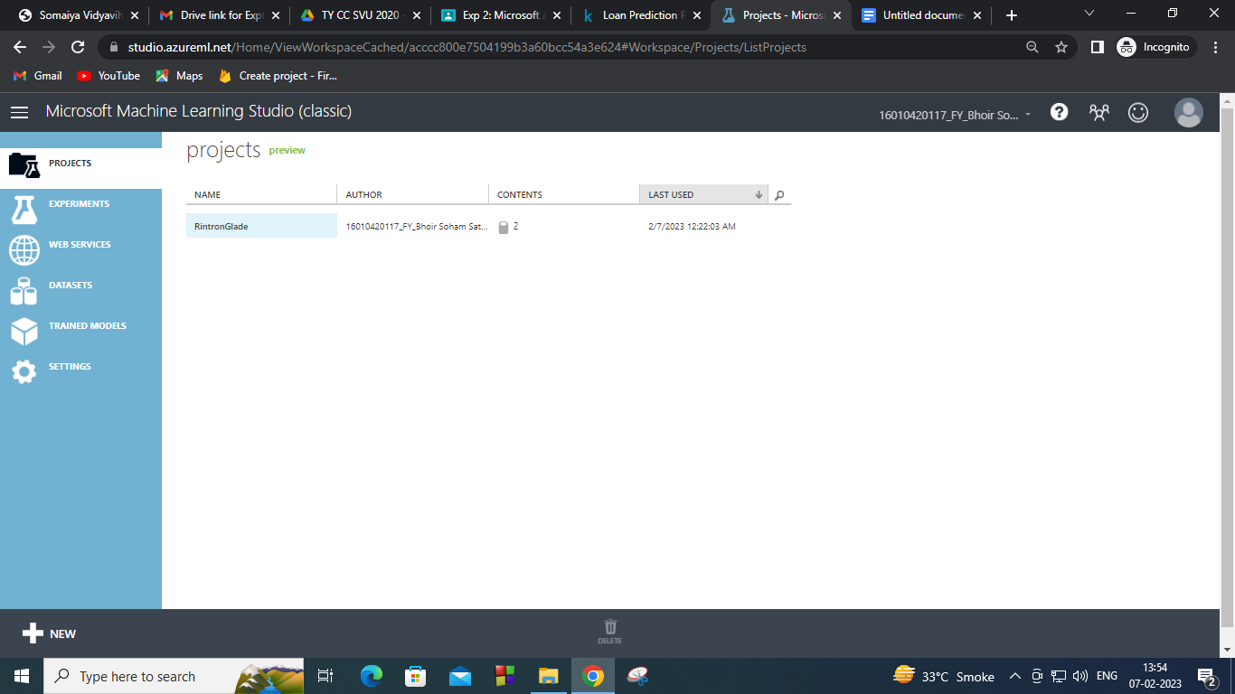

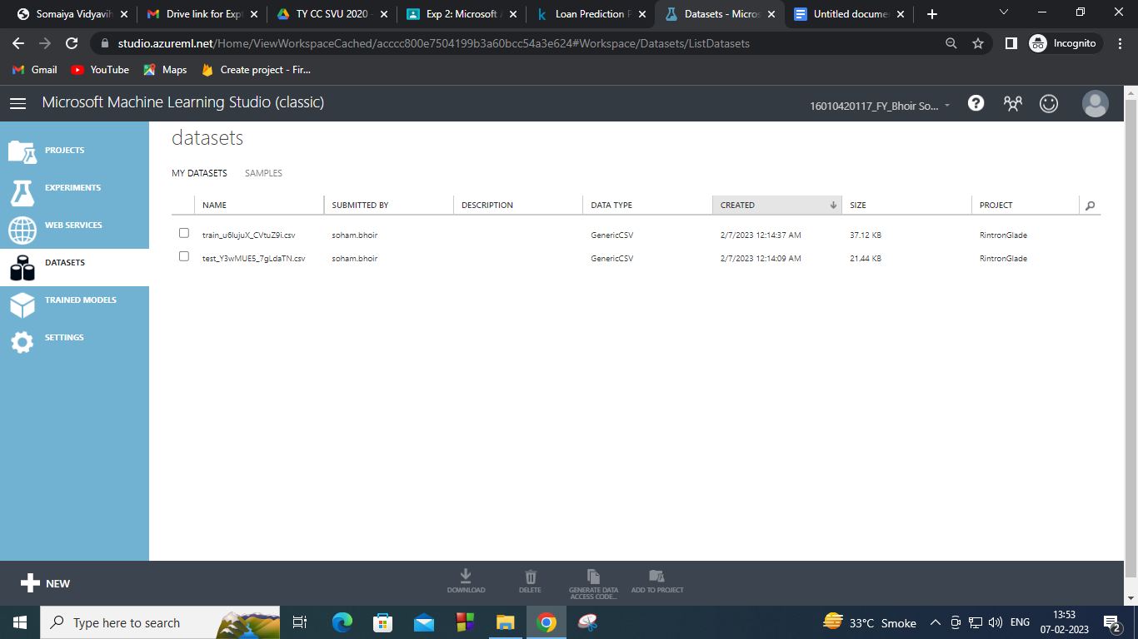

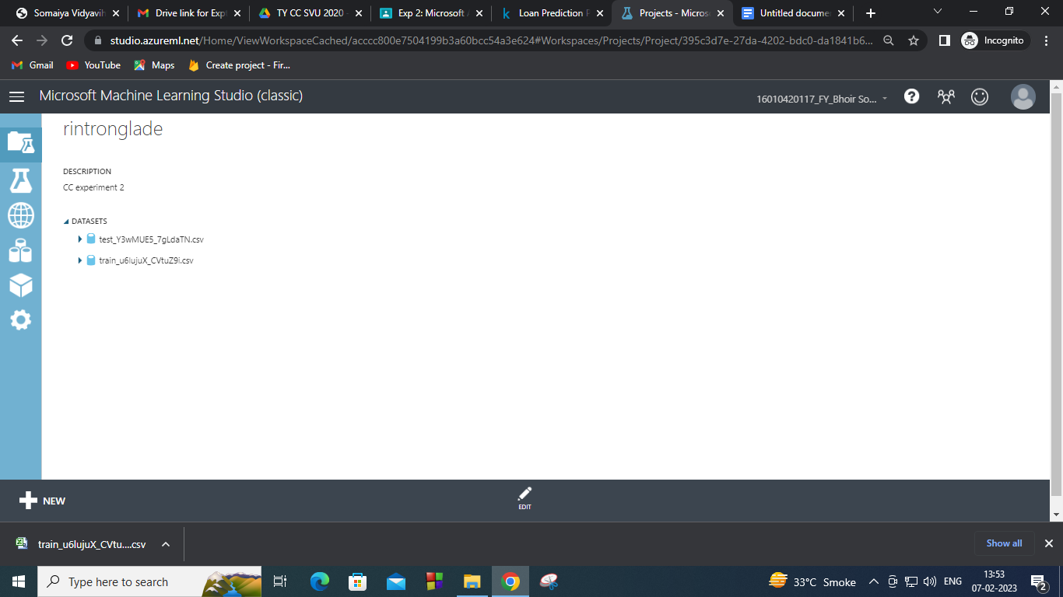

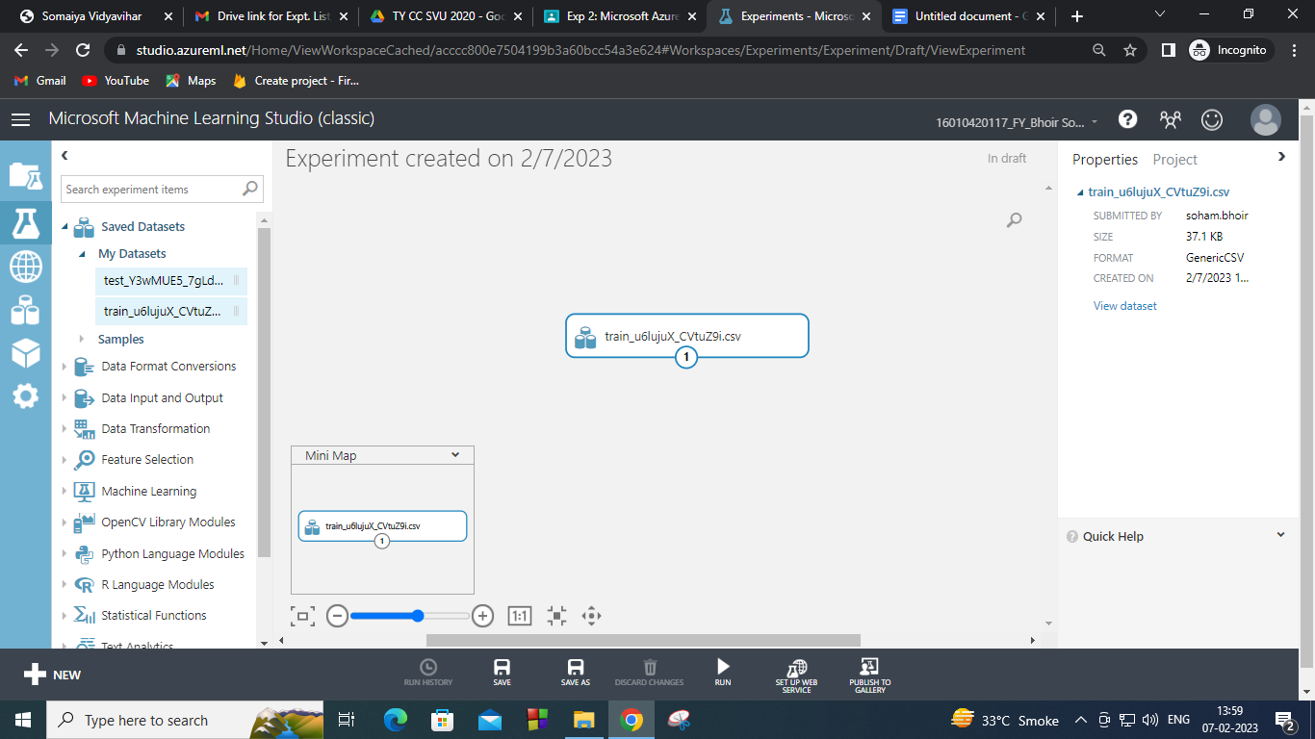

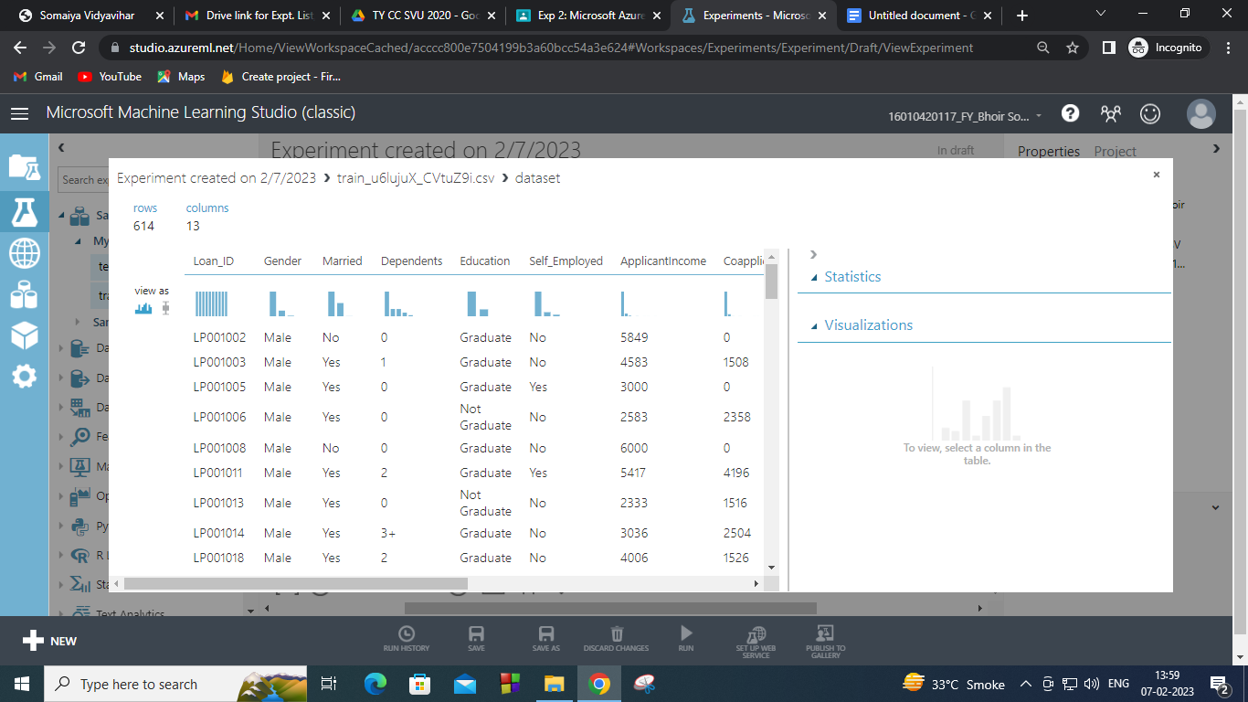

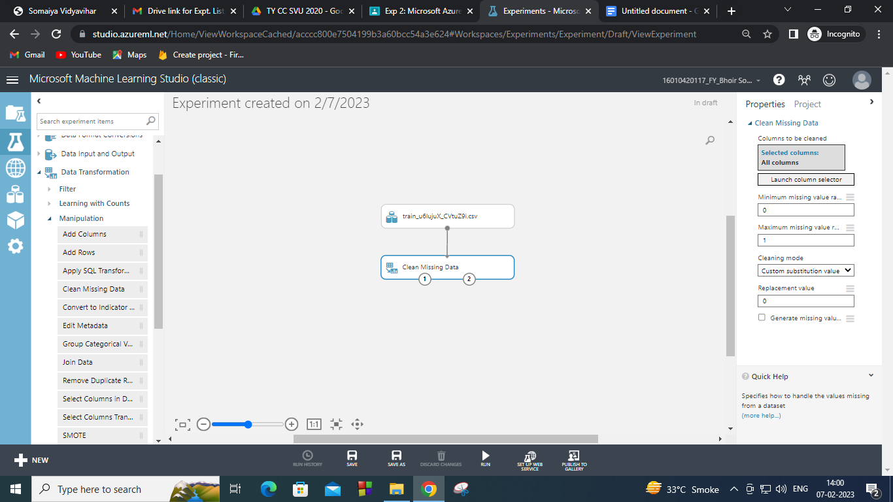

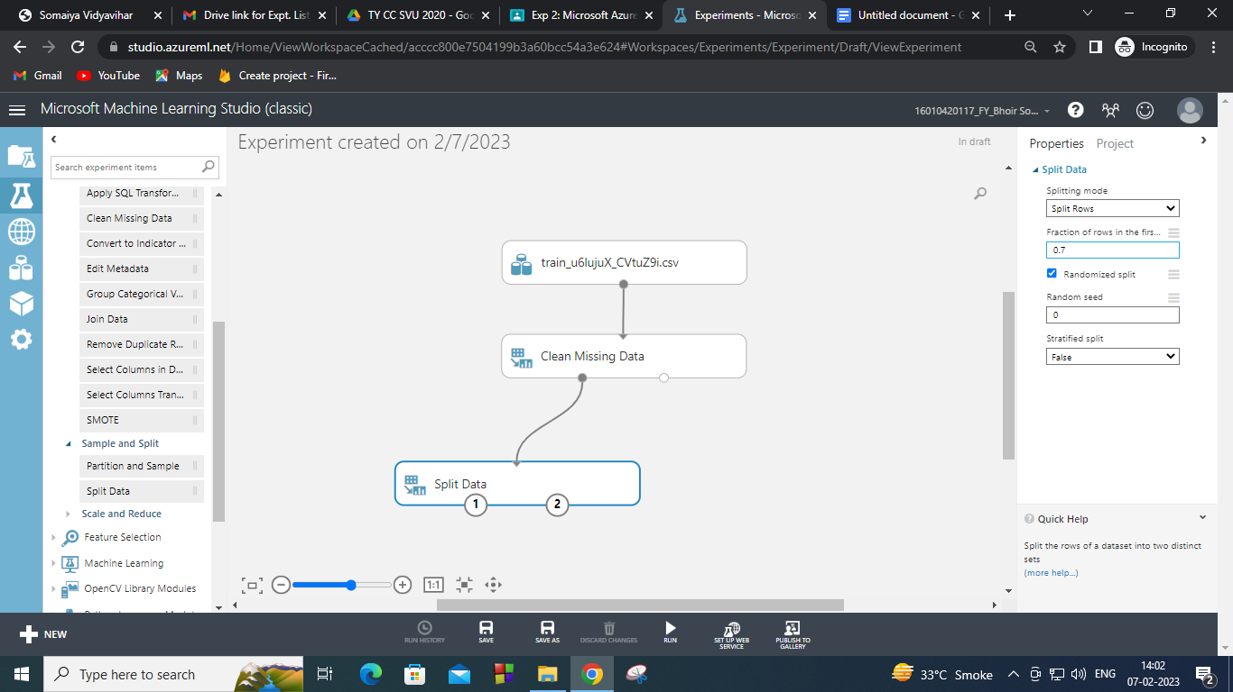

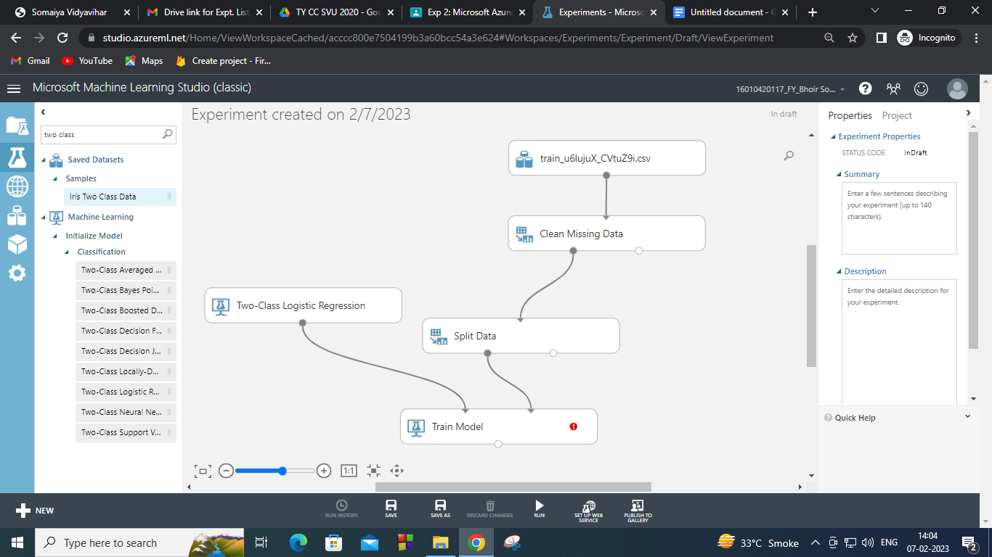

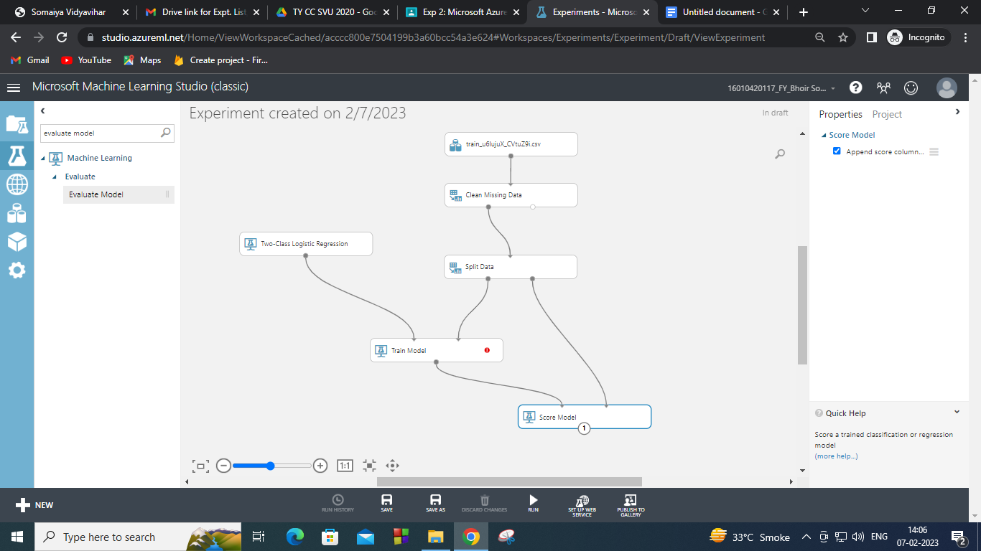

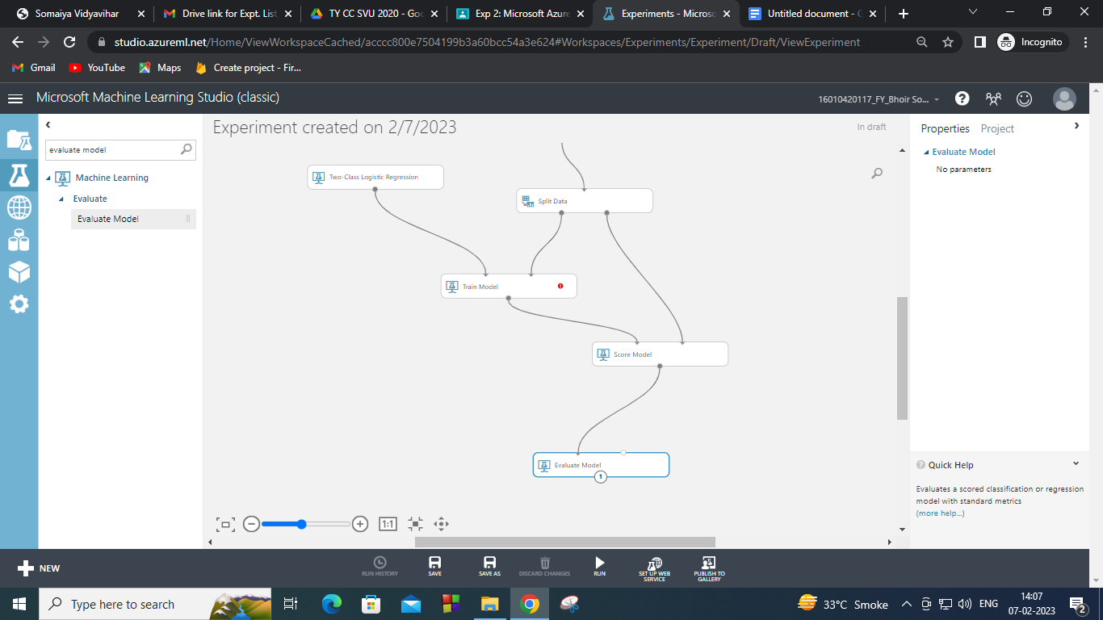

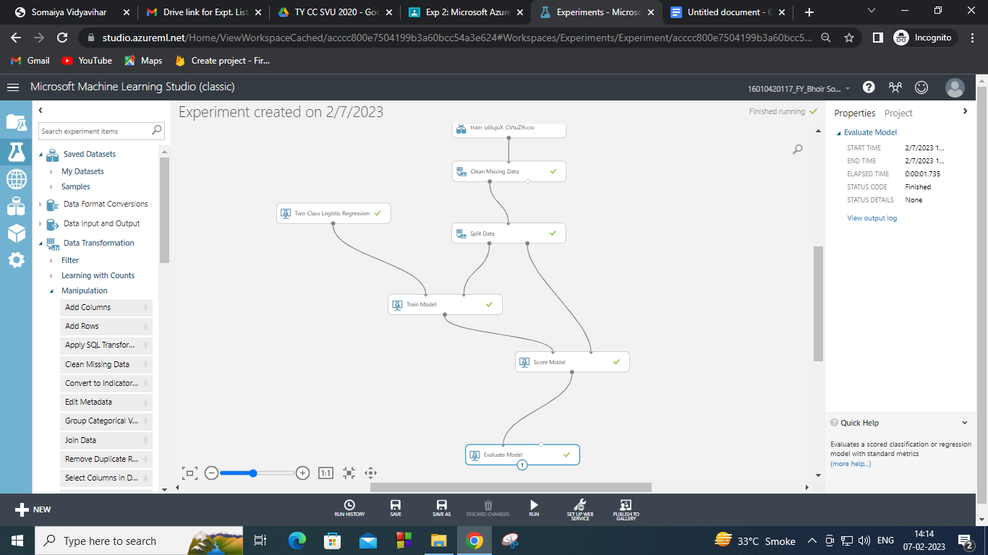

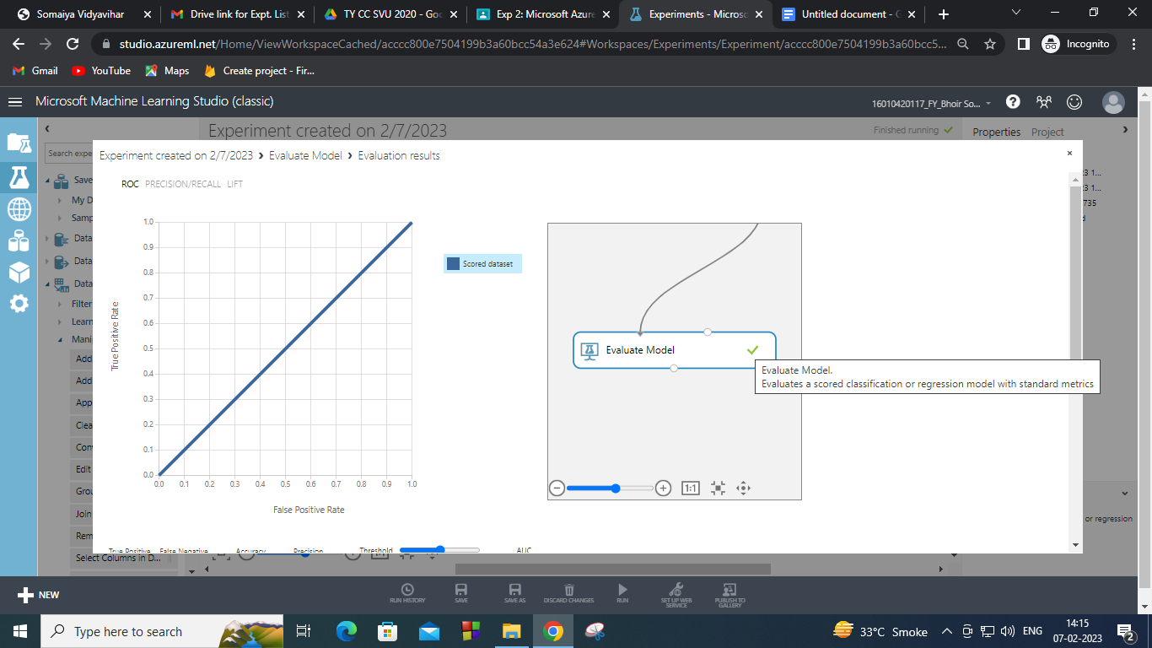

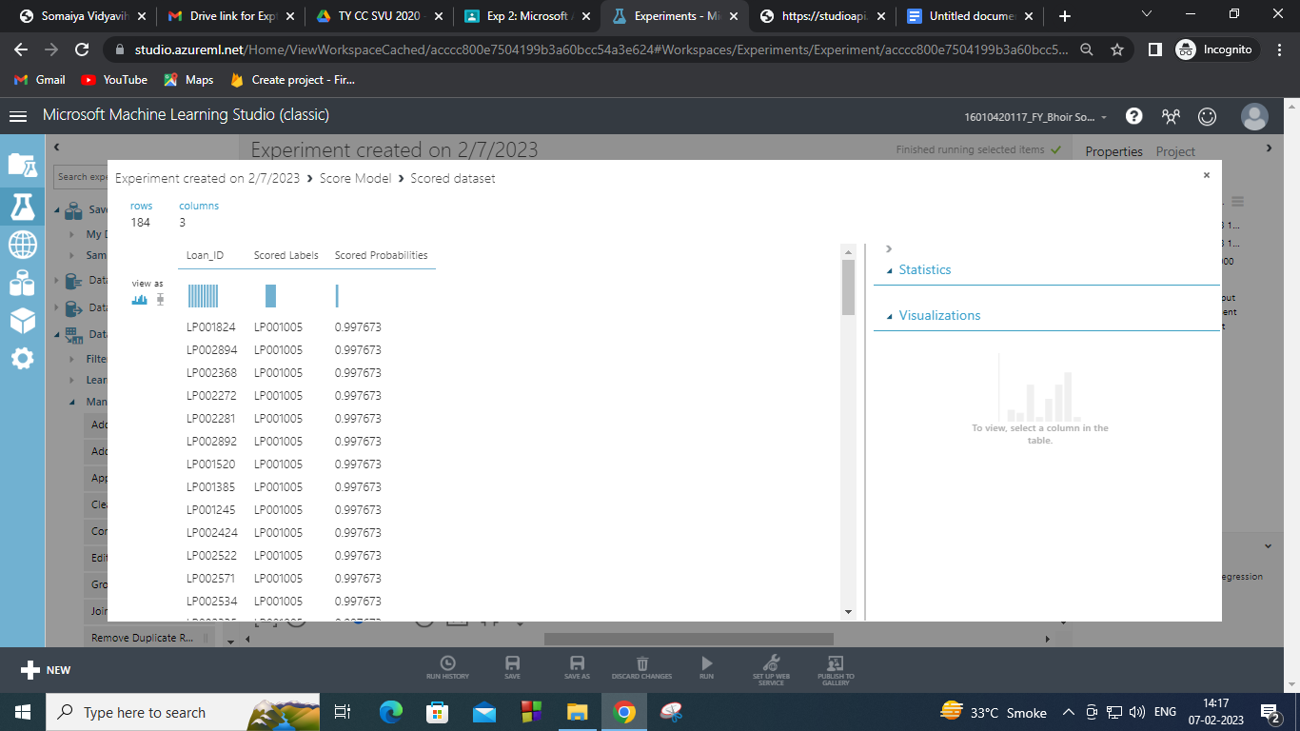

**Post Lab questions:**

Q1. Discuss the tangible and intangible benefits the business has observed after the implementation.

Ans:

**Tangible benefits:**

1. Cash flow will increase.
2. Cash income will increase.
3. Cost reduction will be observed.
4. Increased productivity.
5. Process improvements.
6. Resource cost savings.

**Intangible benefits:**

1. Customer satisfaction.
2. Share rate of the company will increase.
3. Reputation of the company will also increase.
4. Organizational strategy support.
5. Enhanced user experience.
6. Increased customer satisfaction.
7. Greater compliance.
8. Brand equity.

**Outcomes: CO2** : Study the Evolution of Cloud Computing and its models

**Conclusion**: **(Conclusion to be based on the objectives and outcomes achieved)** Implemented and understood Big Data analytics using Microsoft Azure (PaaS) successfully.